**Software Engineering**

System Requirement Specifications

(Group-4)

Project – “ULAB ePlatform”

By –

Md. Feroz Mahmood

Narmeen Afrin

Wasif Adib

Jannatul Ferdous Borna

Nazirul Haque Khan Hridoy

Sadman Sakib

Khandakar Tajri Jannat

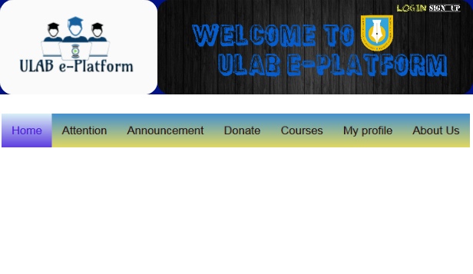

|  |
| --- |
| **Revisions** |

| Version | Primary Author(s) | Description of Version | Date Completed |
| --- | --- | --- | --- |
|  |  |  |  |

|  |
| --- |
| **Review & Approval** |

Requirements Document Approval History

| Approving Party | Version Approved | Signature | Date |
| --- | --- | --- | --- |
|  |  |  |  |
|  |  |  |  |

Requirements Document Review History

| Reviewer | Version Reviewed | Signature | Date |
| --- | --- | --- | --- |
|  |  |  |  |
|  |  |  |  |
|  |  |  |  |

|  |
| --- |
| **Contents** |

1. Introduction 3

2. General Description 3

3. Functional Requirements 4

4. Interface Requirements 5

4.1 User Interfaces 5

4.2 Hardware Interfaces 5

4.3 Communications Interfaces 5

4.4 Software Interfaces 5

5. Performance Requirements 5

6. Other non-functional attributes 6

6.1 Security 6

6.2 Binary Compatibility 6

6.3 Reliability 6

6.4 Maintainability 6

6.5 Portability 6

6.6 Extensibility 6

6.7 Reusability 6

6.8 Application Affinity/Compatibility 7

6.9 Resource Utilization 7

6.10 Serviceability 7

7. Operational Scenarios 7

8. Preliminary Use Case Models and Sequence Diagrams 8

8.1 Use Case Model 8

8.2 Sequence Diagrams 9

9. Updated Schedule 10

10. Updated Budget 10

11. Appendices 10

11.1 Definitions, Acronyms, Abbreviations 10

1. Introduction

* 1. **Introduction**

This is a project about ULAB ePlatform. We are here to develop a product which will generalize the complete details of the information based on ULAB. The academy, the faculties, also the students.

* 1. **Scope of this Document**

We have already signed the NDA with Mr. Anowarul Abedin to sell this product. The cost function agreement is also signed. And so here we are to make the SRS ready. Our team members are Feroz, Narmeen, Wasif, Tajri, Ridoy, Borna, Sadman.

* 1. **Overview**

This product is very efficient for ULAB. We will provide a complete site where all the details of ULAB will be provided. About the faculties, the academy, the students. There will be a total inter communication between them. Where students will be benefitted about the current curriculams also the previous records of academy and faculty. They will also be able to get help if they need about any specific topic. There is also a attention seeking sector where they will be able to recognize them through their works. Overall this information based site will be very much useful for the ULAB community.

* 1. **Business Context**

As it applies to this project, The Intellectual Disabilities Agency of the New River Valley is a non-profit organization that supports people struggling with intellectual disabilities through holding fundraisers and silent auctions to raise aid as well as awareness

## 2. General Description

**2.1 Product Functions**

The product should make input of data and the entire checkout process easier and streamlined for the users (employees) and time efficient for the bidder.

**2.2** **Similar System Information**

The product is being developed with Access, so there are a large number of similar databases or systems and they are used for a wide array of different purposes. The possible strength our system has over the majority is the Excel import/export feature of the program.

**2.3 User Characteristics**

The users include the employees of the IDA as they input data on bids and their bidders. For this system, the user is required to know the basic usability of Excel as well as a very base level understanding of access, which hopefully will be facilitated by the software team through training.

**2.4 User Problem Statement**

The users system, currently, is slow and inefficient as it relates to the checkout process. Bidders must wait hours to check out the item they have won. Too many man hours have been needed to enter the wealth of information collected.

**2.5 User Objectives**

The user wants a database that will store information on a silent auction. The program must faciliatate the speed and ease of input. It also must store the items the IDANRV needs to store.

**2.6 General Constraints**

Constraints include an easy to use interface for the program through forms, a Windows platform or, at bare minimum, a Mac with Access and Excel for Mac installed. Also, it must be constructed in Access, Excel, or another related program that is easily learnable.

## 3. Functional Requirements

1. **Items provided to the Site shall be stored in the Access Database.**
   1. Attention Post
   2. Discussion Post
   3. Help Seeking Post
2. **The items shall be accessible via queries and reports.**
   1. Attention Post – Users are attracted here for any upcoming events or programs that should be noticed by the general regular users.
   2. Discussion Post – Here, everyone will be able to discuss there regular work or about any specific idea or upcoming event or project that will be generalized through two or more users.
   3. Help Seeking Post – Everyone shall be able to ask for any kind of help here. If they lost something in the university campus, they shall be able to ask the lost item here in this sector.
3. **The data stored should be able to be manipulated through forms.**
   1. Items and other data should be able to be added and updated through the use of forms.
   2. Very high criticality
   3. We do not foresee any technical risks involved in this requirement.
   4. The only factor we can encounter here is the user of the system not being able to use it correctly. We will overcome this by training those who will be using it.
   5. This requirement is dependent on requirement one.

## 4. Interface Requirements

4.1 User Interfaces

* **4.1.1 GUI**  
  The user interface for this program is the interface provided by Microsoft Access 2007. Access includes forms and reports for the users to query and organize data to suit their needs. Forms and reports both have builders that let the user specify which fields they want to use and which constraints they want to define.
* **4.1.2 CLI**  
  There is no command line interface
* **4.1.3 API**  
  There is no API for the product
* **4.1.4 Diagnostics or ROM**  
  There is a troubleshooting and help section provided by Microsoft

4.2 Hardware Interfaces

The program (Access) uses the hard disk. Access to the hard drive and other hardware is managed by the operating system and Access.

4.3 Communications Interfaces

If we decide to implement an Ad Hoc network for a shared database, the operating system will handle those connections.

4.4 Software Interfaces

The Access system may be used to import and export data with Microsoft Excel. This functionality is built in to the user interface.

## 5. Performance Requirements

The database is designed to be operated through Microsoft Access 2007, thus no additional system requirements exist beyond those required to run Microsoft Office 2007, except for a negligible amount of hard drive space to store the database.

Microsoft lists the requirements for Access 2007 as follows:

500 MHz processor or higher

1 GB RAM or higher

2 GB Available Hard Drive Space

Windows – 7 / 8 / 8.1 / 10 or later operating system.

Windows Office Professional 2007 (Windows Access)

There is also Access Available for Mac OS X, the clients have not stated a need thus far.

## 6. Other non-functional attributes

.

### 6.1 Security

The system shall be designed with a level of security appropriate for the sensitivity of information enclosed in the database. More interaction is needed with client about the volatility of the information. Since there is no obvious information that is of a high security level such as credit card information, the only requirements that could be implemented are encrypting the database and/or making the database password-protected, by user’s request.

### 6.2 Binary Compatibility

This system will be compatible with any computer that has Microsoft Office Professional 2007 or later installed (whether PC or Mac), and will be designed with more than one computer in mind.

### 6.3 Reliability

Reliability is one of the key attributes of the system. Back-ups will be made regularly so that restoration with minimal data loss is possible in the event of unforeseen events. The system will also be thoroughly tested by all team members to ensure reliability.

### 6.4 Maintainability

The system shall be maintained by Sheila Roop, of the IDA, or delegated to another employee.

### 6.5 Portability

The system shall be designed in a way that shall allow it to be run on multiple computers with Microsoft Office Professional 2007 or later installed.

### 6.6 Extensibility

### The system shall be designed and documented in such a way that anybody with an understanding of Microsoft Access shall be able to extend the system to fit their needs with the team’s basic instructions.

### 6.7 Reusability

The system should be designed in a way that allows the database to be re-used regularly for the various silent auctions that the organization shall hold.

### 6.8 Application Affinity/Compatibility

This system requires the Microsoft Office Professional 2007 suite or later, as it operates primarily through Microsoft Access, in conjunction with Microsoft Excel.

### 6.9 Resource Utilization

The resources used in the creation of this system include: Dr. Lewis, the client (Sheila Roop), the computers in Davis Hall, and the internet.

### 6.10 Serviceability

The maintenance of the system should be able to be sufficiently performed by any person with a basic understanding of Microsoft Access.

## 7. Operational Scenarios

**Scenario A: Initial Item Definitions**

The user shall enter the information about the items into the database for its initial construction and evolution. The fields will be completed via a form that will manipulate the data.

**Scenario B: Customer Check-out**

The user shall be able to enter information about the customer purchasing a particular item, and record their bid and other information. They will also enter the winning bid

**Scenario C: Database Maintenance**

The user may want to alter/delete information after the auction is over, In this case they will need to be able to remove the data that has been entered.

## 8. Preliminary Use Case Models and Sequence Diagrams

This section presents a list of the fundamental sequence diagrams and use cases that satisfy the system’s requirements. The purpose is to provide an alternative, "structural" view of the requirements stated above and how they might be satisfied in the system.

8.1 Use Case Model

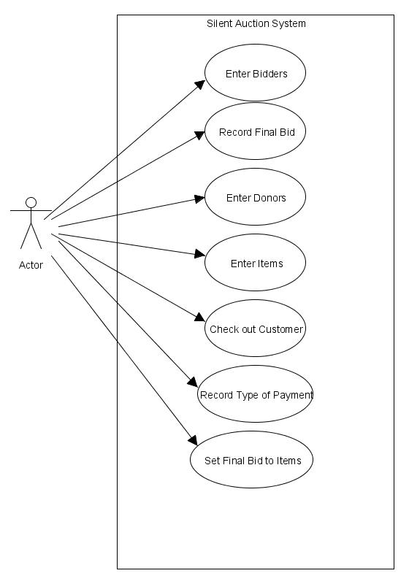

8.2 Sequence Diagrams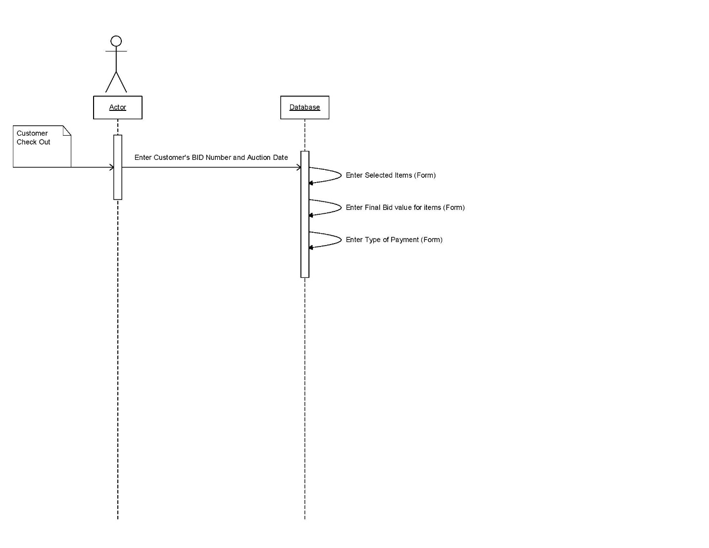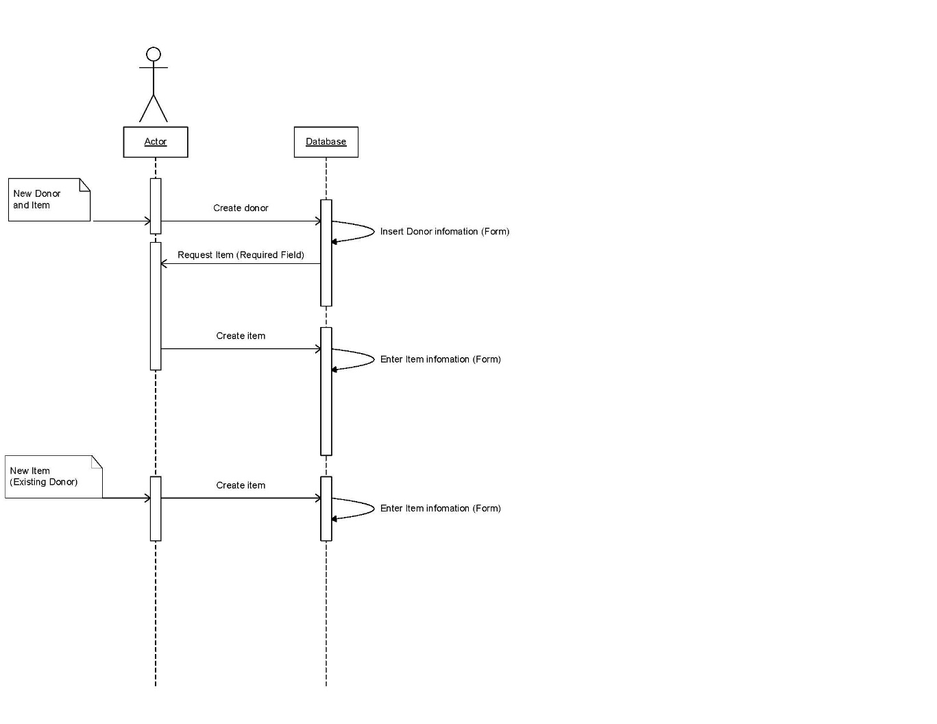

## 9. Updated Schedule

The updated PERT/GANTT chart is attached at the end of the document

## 10. Updated Budget

An updated budget is attached at the end of this document

## 11. Appendices

11.1 Definitions, Acronyms, Abbreviations  
IDANRV- Intellectual Disabilities Agency of the New River Valley